MIDTOWNERS SUNSHINE OF THE WEEK ► September 7th, 2007
Birthday of Rtn. Mahendra Shrestha on September 10th
Birthday of Beena Jyoti, spouse of CP Roop on September 10th

SPEAKER OF THE WEEK ► HE Ambassador of Malaysia to Nepal
EVENT | DINNER MEETING
Please join us for our first dinner meeting of the year. The meeting will be held at Hotel Malla on Friday, September 7, 2007. Registration and fellowship will begin at 6PM, and the meeting will commence at 6:30PM. Members are encouraged to bring spouses and guests.

UPCOMING SPEAKERS ► PREVIEW
DATE | SPEAKER | THEME
Sept 14th | PP William Ma | Orientation about Rotary
Sept 21st | Shyam Thapaliya | Tourism Entrepreneurship
Sept 28th | Dr. Som Pudasaini | Conflict Resolution and Peace Building

THE MID-TOWN CLUB ► NEWS
Last Week’s Speaker
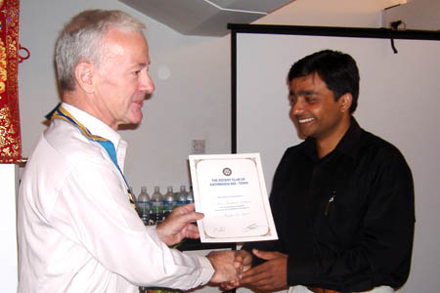
Guest Speaker Om Prakash Yadav receiving Letter of Appreciation from President Walter
SCENES FROM LAST WEEK’S MEETING
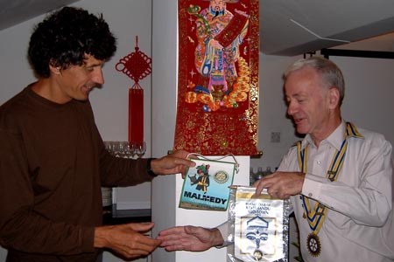 |  | 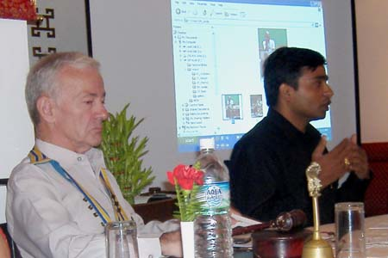
President Walter exchanging flags with Rotarian from Belgium |  | Om Yadav talks about photography as President Walter looks on
ROTARACT NEWS
ROTARY/ROTARACT shared concern for disabled children in the New Generation month SEPTEMBER by donating 7 wheel chairs to disabled children on September 3rd. PP Dr Chandra Lekha, along with Rotarians of Kathmandu Metro – Secretary Rtn Rajib Pokhrel, Community Service Director Rtn Mishra – and Rotaracts of Kathmandu Mid-Town visited the CBR Community Based Rehabilitation center of Nepal Disabled Women Society at Godavari to donate the wheel chairs made available by RC Kathmandu Metro. The Rotaract Club contributed the transportation charges.
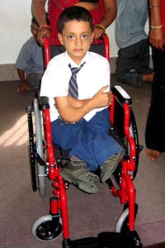 | 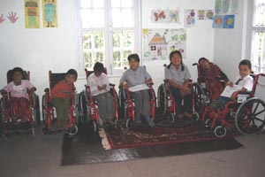 |  | 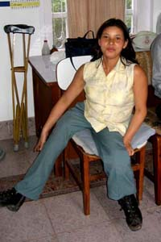

THE ROTARY INTERNATIONAL ► Responsibilities of Club Membership
The club is the cornerstone of Rotary, where the most meaningful work is carried out. All effective Rotary clubs are responsible for four key elements: sustaining or increasing their membership base, participating in service projects that benefit their own community and those in other countries, supporting. The Rotary Foundation of RI financially and through program participation, and developing leaders capable of serving in Rotary beyond the club level. What Rotarians get out of Rotary depends largely on what they put into it. Many membership requirements are designed to help members more fully participate in and enjoy their Rotary experience.
Attendance Attending weekly club meetings allows members to enjoy their club’s fellowship, enrich their professional and personal knowledge, and meet other business leaders in their community. Many larger communities offer clubs with different meeting times, including early morning, the lunch hour, after work, and evening. If members miss their own club’s meeting, they’re encouraged to expand their Rotary horizons by attending make-up meetings at any Rotary club in the world — a practice that guarantees Rotarians a warm welcome in communities around the globe. Find meeting places and times in the Official Directory or through the Club Locator at www.rotary.org. In some cases, Rotarians can make up meetings by participating in a club service project or attending a club board meeting or a Rotaract or Interact club meeting. Members can also make up online at one of several Rotary e-clubs.
Service All Rotary clubs share a key mission: to serve their community and those in need throughout the world. By participating in club service projects, members learn about their club’s involvement in local and international projects and can volunteer their time and talents where they are most needed.
Membership recruitment and retention To keep clubs strong, every Rotarian must share the responsibility of bringing new people into Rotary. Even new members can bring guests to meetings or invite them to participate in a service project. The value of Rotary speaks for itself, and the best way to spark the interest of potential members is by letting them experience fellowship and service firsthand. Keeping members interested in Rotary is another responsibility. Good club fellowship and early involvement in service projects are two of the best ways to sustain the club’s membership. The ideal composition of a Rotary club reflects the community’s demographics, including professions, gender, age, and ethnicity. Such diversity enriches every aspect of the club’s fellowship and service.
- From Rotary Basics

Editor: Rabi Karmacharya, Club Service Director email: rabikarma@gmailcom

